Embedded Documents Assignment

Insert the following documents to a collection named “record”
[
{
"_id": 1,
"name": "Ramandeep Kaur",
"age": 21,
"address": {
"street": "123 Maple Street",
"city": "Chandigarh",
"state": "Punjab",
"zip": 160001,
"coordinates": { "lat": 30, "long": 76 }
},
"courses": [
{ "courseName": "Mathematics", "grade": "A", "marks": 95 },
{ "courseName": "Physics", "grade": "B+", "marks": 88 }
]
},
{
"_id": 2,
"name": "Arjun Singh",
"age": 22,
"address": {
"street": "45 Rose Avenue",
"city": "Amritsar",
"state": "Punjab",
"zip": 143001,
"coordinates": { "lat": 31, "long": 74 }
},
"courses": [
{ "courseName": "Chemistry", "grade": "A-", "marks": 90 },
{ "courseName": "Biology", "grade": "B", "marks": 82 }
]
},
{
"_id": 3,
"name": "Simran Kaur",
"age": 20,
"address": {
"street": "78 King Street",
"city": "Ludhiana",
"state": "Punjab",
"zip": 141001,
"coordinates": { "lat": 30, "long": 75 }
},
"courses": [
{ "courseName": "English", "grade": "A+", "marks": 98 },
{ "courseName": "History", "grade": "A", "marks": 92 }
]
},
{
"_id": 4,
"name": "Manpreet Singh",
"age": 23,
"address": {
"street": "56 Park Lane",
"city": "Jalandhar",
"state": "Punjab",
"zip": 144001,
"coordinates": { "lat": 31, "long": 75 }
},
"courses": [
{ "courseName": "Computer Science", "grade": "A", "marks": 93 },
{ "courseName": "Mathematics", "grade": "B+", "marks": 87 }
]
},
{
"_id": 5,
"name": "Harleen Kaur",
"age": 21,
"address": {
"street": "90 Green Road",
"city": "Patiala",
"state": "Punjab",
"zip": 147001,
"coordinates": { "lat": 30, "long": 76 }
},
"courses": [
{ "courseName": "Physics", "grade": "A-", "marks": 89 },
{ "courseName": "Chemistry", "grade": "B+", "marks": 85 }
]
},
{
"_id": 6,
"name": "Rohan Verma",
"age": 22,
"address": {
"street": "33 Lake View",
"city": "Mohali",
"state": "Punjab",
"zip": 160055,
"coordinates": { "lat": 30, "long": 76 }
},
"courses": [
{ "courseName": "Economics", "grade": "A", "marks": 91 },
{ "courseName": "Political Science", "grade": "B", "marks": 84 }
]
}
]

Assignment Questions
- Find students who have a course with courseName “Mathematics” and grade “B+”.
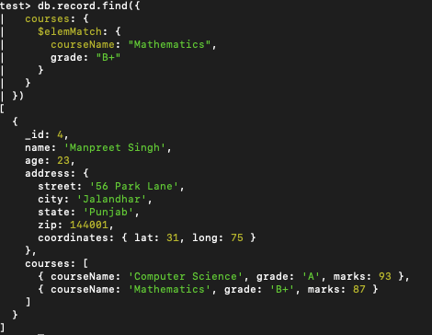
- Find students who are older than 20 and have at least one course with grade “A”.
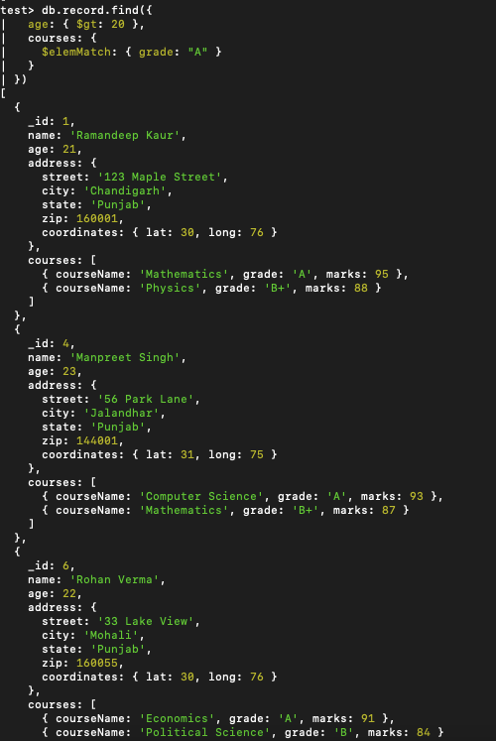
- Find students who have a course with courseName “Physics” and marks greater than 85.
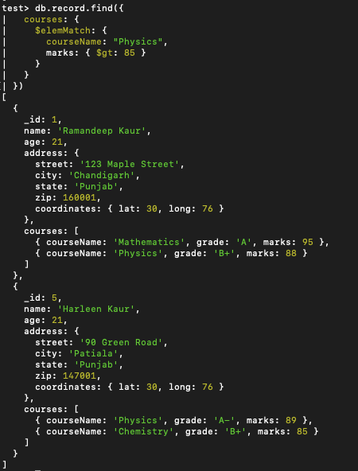
- Find students who have at least one course with marks > 85 and marks <= 90.
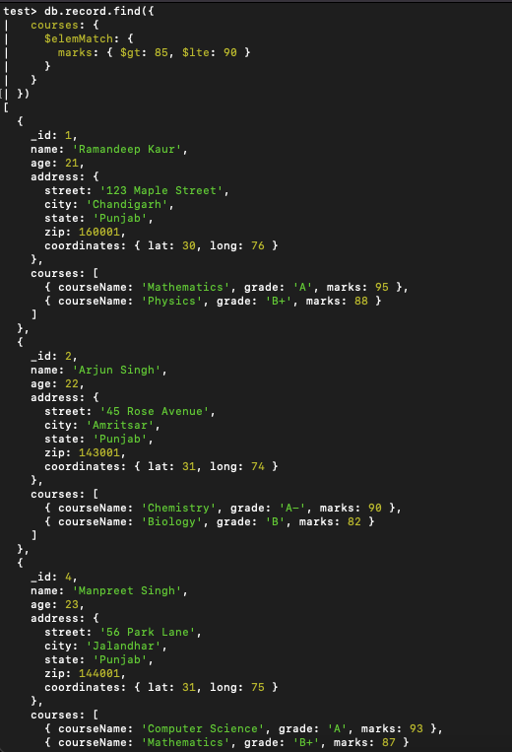
- Find students who have one course with marks > 90 and same or another course with grade “B+”.
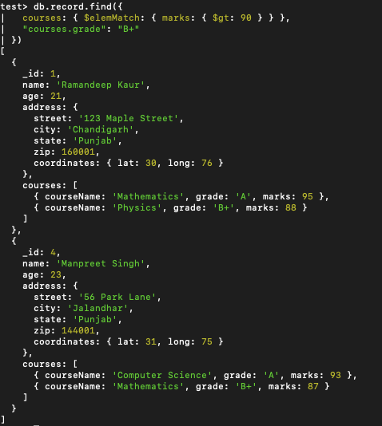
- Find students who have one course with marks > 90 and another course with marks <= 88.
